Лабораторна робота 9(5)

Варіант 18

1. STL3Alg18

#include <iostream>

#include <deque>

#include <algorithm>

using namespace std;

int main() {

int N = 5;

deque<int> d(2*N);

generate(d.begin(), d.begin()+N, [n=1] () mutable { return n++; });

generate(d.rbegin(), d.rbegin()+N, [n=N] () mutable { return n--; });

for (int i : d) {

cout << i << " ";

}

cout << endl;

return 0;

}

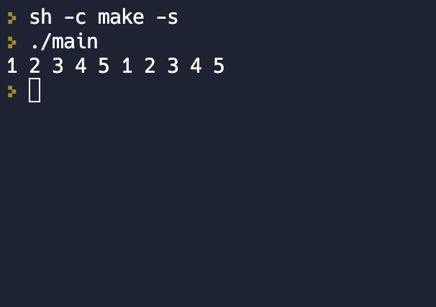

1. STL5Assoc18

#include <iostream>

#include <vector>

#include <algorithm>

#include <map>

#include <string>

int main() {

std::vector<std::string> words {"APPLE", "ANT", "BANANA", "BALL", "CAR", "CAT", "DOG", "DAY", "EAGLE", "EYE"};

std::map<char, int> length_by_letter;

std::for_each(words.begin(), words.end(), [&length_by_letter](const std::string& word) {

++length_by_letter[word[0]];

length_by_letter[word[0]] += word.length() - 1;

});

std::for_each(length_by_letter.begin(), length_by_letter.end(), [](const std::pair<char, int>& pair) {

std::cout << pair.first << ": " << pair.second << std::endl;

});

return 0;

}

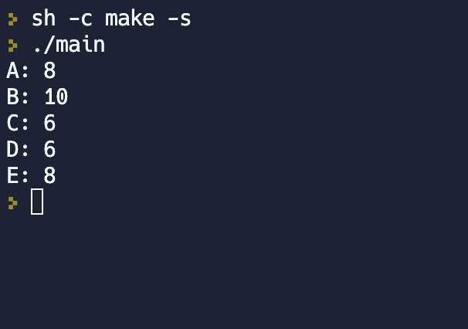

1. STL7Mix18

#include <iostream>

#include <map>

#include <set>

#include <string>

#include <vector>

#include <algorithm>

using namespace std;

int main()

{

vector<string> data = {

"1 2022 Ivanov",

"2 2021 Petrov",

"3 2022 Sidorov",

"2 2022 Smith",

"4 2021 Johnson",

"1 2021 Brown",

"3 2021 Garcia",

"5 2022 Davis",

"4 2022 Miller",

"5 2021 Wilson",

"1 2022 Anderson",

"2 2021 Martin"

};

map<int, set<int>> years;

for (const auto& line : data) {

int school, year;

string surname;

sscanf(line.c_str(), "%d %d %s", &school, &year, &surname[0]);

years[year].insert(school);

}

vector<pair<int, int>> stats;

for (const auto& [year, schools] : years) {

stats.emplace_back(schools.size(), year);

}

sort(stats.begin(), stats.end());

for (const auto& [schoolsCount, year] : stats) {

cout << schoolsCount << " " << year << endl;

}

return 0;

}

